Discussion Question 1  
In an experiment in which cardiac fast action potentials were measured it was observed that administration of a particular drug resulted in a decrease in the duration of phase 2 along with more of a “droop” (negative slope) in phase 2. Please provide a possible explanation for these observations. Answer individually;

The phase of the cardiac fast action potential, during which the membrane potential declines slowly, is known as plateau phase or phase 2. It is the result of a balance between an influx of Ca2+ entering the cell through calcium channels and the efflux of potassium moving out of the cell through delayed rectifier channels. If the influx calcium is reduced, the efflux of K+ becomes to dominate and will change the duration of phase 2 and the “droop” in phase 2: the duration becomes shorter and the slope more negative. Compared to T-type calcium channels, L-type calcium channels are more common, remain open longer, and contribute to phase 2. We can assume that this particular drug blocks L-type channels. As the drug blocks L-type calcium channels, less calcium ions enter the cell, altering the balance between the efflux of K+ and influx of Ca2+. Phase 2 duration becomes shorter and slope is more negative (similar to what is happening in fig.1).

We can also imagine that the drug instead of blocking calcium channels, increases potassium conductance by increasing either the duration of the rapid current IKr or delaying less the slowing activating current IKs which then rises earlier during phase 2 (Fig.2). More potassium ions move out of the cell and the influx of Ca2+ is counterbalanced less in time and in duration by the efflux of K+.

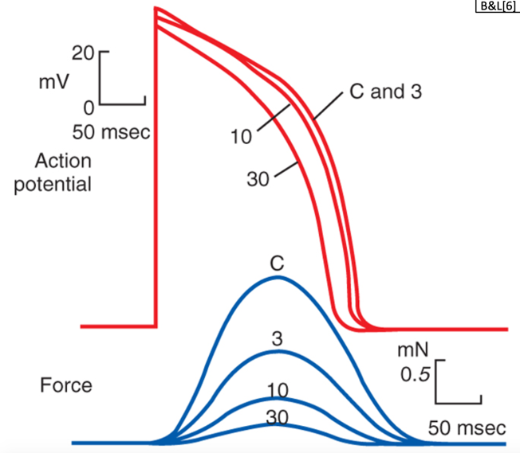

**Fig. 1**: With increase concentrations of diltiazem, the plateau duration diminishes and the plateau voltage becomes less positive (more “droop”) (video 3, slide 3)

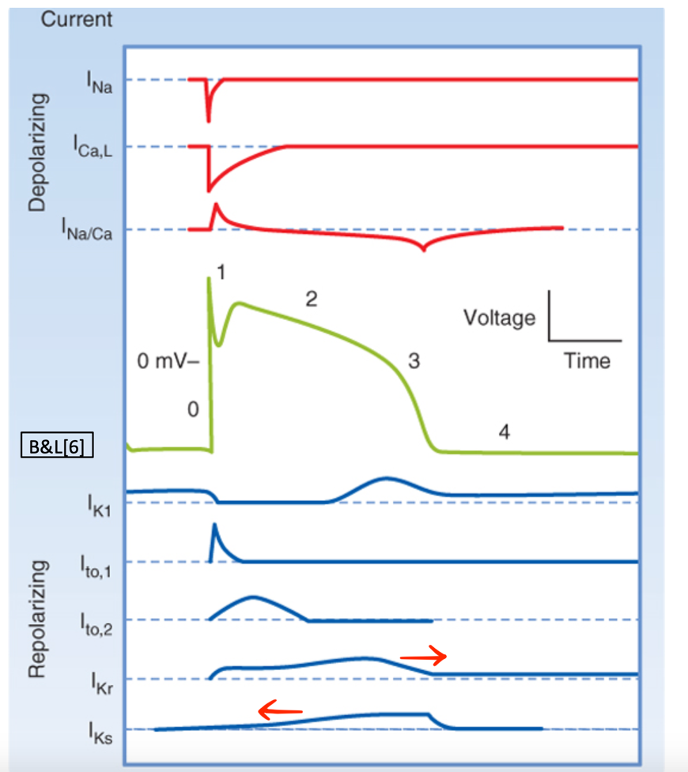

**Fig.2:** delayed rectifier K+ currents IKr , being extended later into the early recovery phase and IKs starting earlier during the phase 2.

Discussion Question 2  
What would be the effect of a drug that reduces T-type Ca2+ current on the time to reach threshold in a cardiac pacemaker potential? Briefly explain. Answer individually;

The T-type Ca2+ current (T = transient) participates to the end of the slow depolarization observed during phase 4, the portion of the membrane potential recording leading to threshold potential (Fig. 1). The drug reducing T-type Ca2+ current affects the slope of the end of phase 4 of the cardiac pacemaker potential like described in figure 2. As less calcium ions enter the cell and depolarize it more gradually, it takes longer to reach the threshold potential, which then diminishes the frequency of pacemaker firing and decreases the heart rate.

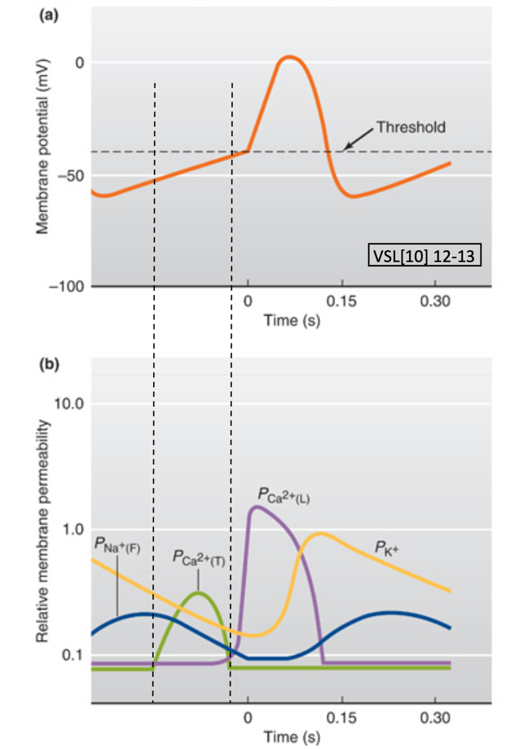

**Fig. 1**: Membrane potential and ionic movements in each phase VSL [15] 12-16

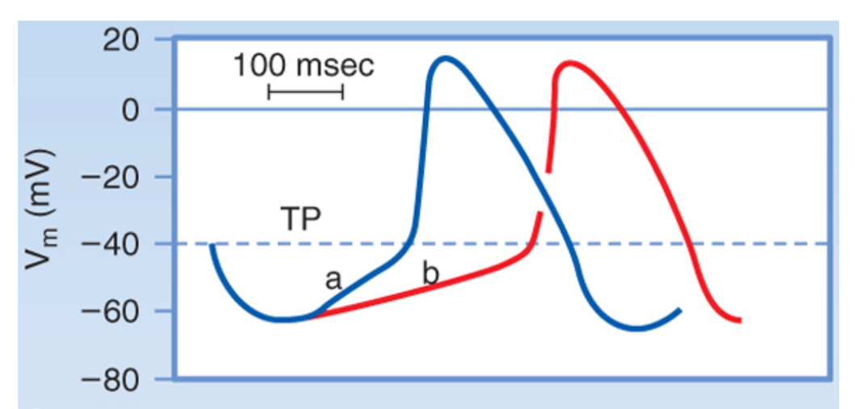

**Fig 2**: decrease in T-type Ca2+ current from [a] to [b] reduces the slope of depolarization at the end of phase 4, resulting in slower depolarization towards the end of phase 4 (video 4, slide 5).Discussion Question 3  
What would be the effect of a drug that reduced L-type Ca2+ current in AV nodal cells on the timing of the EKG waveform? Briefly explain. Answer individually;

The reduction of inward L-type Ca2+ current, iCa, diminishes the slope of the slow diastolic depolarization (phase 4) and the amplitude of the action potential (phase 0). As a result, there is a decrease of the conduction through the AV node. The PR segment (see figure below), on the EKG waveform, is after the P wave and before the QRS complex and represents the time in which the cardiac impulse is traveling through the AV node and the bundle of His. A decrease of the conduction velocity through the AV node increases the length of this time interval.

As a consequence, the P-R interval, which is measured from the beginning of the P wave to the beginning of QRS complex and reflects the time, it takes for a cardiac impulse to travel from the SA node through the AV node, also increases. Consequently there is a decrease of the heart rate.

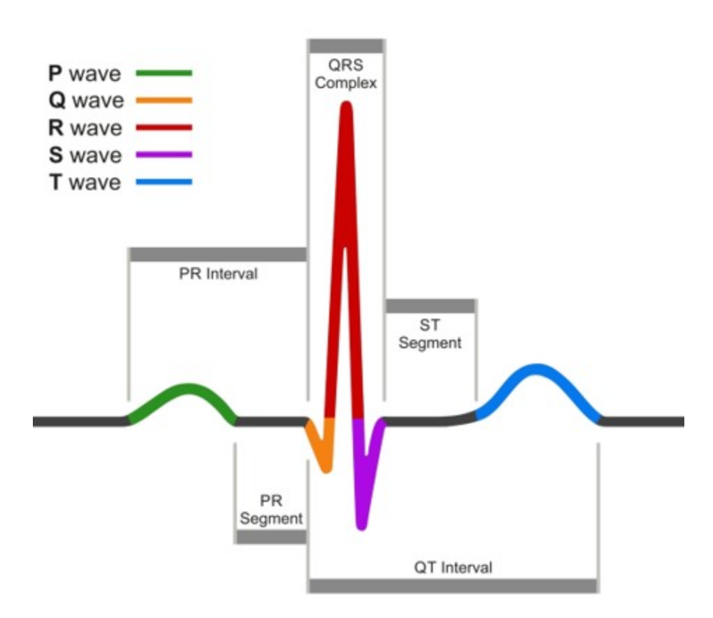

EKG waveform